Project Design Phase-I

**Solution Architecture**

|  |  |
| --- | --- |
| Date | 15 MAY 2023 |
| Team ID | NM2023TMID14672 |
| Project Name | Uncovering the hidden treasures of the mushroom kingdom a classification analysis |

**Solution Architecture:**

Solution architecture is a complex process – with many sub-processes – that bridges the gap between business problems and technology solutions. Its goals are to:

* Find the best tech solution to solve existing business problems.
* Describe the structure, characteristics, behavior, and other aspects of the software to project stakeholders.
* Define features, development phases, and solution requirements.
* Provide specifications according to which the solution is defined, managed, and delivered.

**Example - Solution Architecture Diagram:**

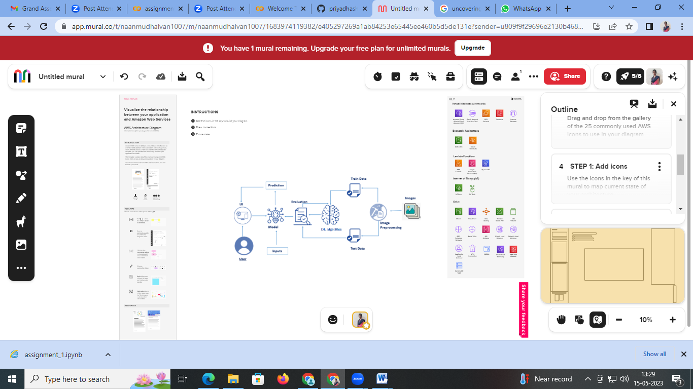

*Figure 1: Architecture and data flow of the voice patient diary sample application*

**Reference:https://app.mural.co/t/naanmudhalvan1007/m/naanmudhalvan1007/1683974119382/e405297269a1ab84253e65445ee460b5d5de131e?sender=u809f9f29696e2130b4688490**